**Introduction:**

* ACEIT is a grassroots group that has come together to encourage change that will reform/restore fair elections.
* We have focused on educating Anoka County Commissioners on election vulnerabilities, opportunities, and potential solutions. We have also brought in national experts in cybersecurity to speak to the Commissioners.
* The Commissioners have not shown much interest to-date, responding primarily through their legal team rather than creating a forum to collaborate on improvements to our processes to restore the confidence of the people.
* There are several groups of citizens that are all striving for fair, honest, and transparent elections and we need to unite to be stronger together. There are many facets that must be cared for and all of us are needed in this pursuit.

**Case For Involvement:**

* ACEIT has provided an undeniable case for our Anoka County Commissioners to take action on election reform; but no action has yet been taken. We need to enlarge our Anoka County citizen voice so that our government officials understand they must take action to right the ship. These matters cannot be ignored.
* For every one of us, time is precious; we need to know that any involvement we have is driving change. Working to restore Minnesota to fair and honest elections is a worthy cause because it brings freedom, justice, and liberty to We The People – certainly a high calling/purpose.
* So what can you do to join this effort?

**Action Options:**

1. Watch the 2-minute presentations ACEIT has made to the Anoka County Commissioners. This might be a good way to quickly educate yourself on some of the election concerns and potential solutions. Over the past 6 months there have been >50 presentations that you can select from at: https://www.projectminnesota.com/anoka/?ref=projectminnesota.com
2. Attend the twice monthly Anoka County Commissioner meetings simply to listen in and learn about the election concerns and potential solutions ACEIT presents. Your presence is incredibly powerful as it helps to show the Commissioners your agreement that we need to reform and restore our election processes.
3. 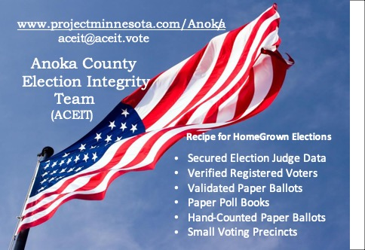Email/write your County Commissioner urging them to act on the following election matters/solutions, which we call the *Recipe for Secure and Transparent Home Grown Elections*. (Communication samples on the back of this page.)
4. Call your County Commissioner urging them to act on the election matters/solutions mentioned above in #3.

**Contact Information:**

* The Anoka County Commissioner board meeting [schedules/calendar](http://www.anokacountymn.gov/calendar.aspx?CID=25) are on the Anoka County website.
* [Phone numbers and email addresses for the County Commissioners](http://www.anokacountymn.gov/693/Board-of-Commissioners) are also on the Anoka County website.
* To identify who your County Commissioner is, use this link to view the map of which Commissioners represent the [district](https://www.anokacountymn.gov/DocumentCenter/View/31572/Commissioner-Districts) that you live in.

**Sample communication regarding returning to paper poll books.**

Dear Commissioner,

Thank you for taking the time to hear from the citizens you are representing. I am reaching out to ask for your attention in the matter of returning to the paper poll books instead of electronic poll pads.

We all know about the security breaches that happen regularly in our country. We know that any time we use electronic solutions we’re at risk of having information and data breached.

Please return to using the simple process of paper registration/poll books to eliminate this risk. That system has worked for decades and does not include the risk of my personal data being hacked and any hacker knowing whether or not I voted. We need secure elections, which cannot be achieved with electronic poll pads.

Please take action now to return to paper poll books.

Thank you,

[your name]

**Sample communication regarding returning to hand-counting all our ballots for each race.**

Dear Commissioner,

Thank you for taking the time to hear from the citizens you are representing. I am reaching out to ask for your attention in the matter of re-instituting hand-counts of every race to obtain the total votes for each candidate.

We have a long history of using hand-counts and they were more reliable than machines, which we know regularly misinterpret markings on the ballots. While machines can bring speed to a process, they automatically bring vulnerabilities regarding breakdowns, errors, and security breaches. We know this happens every day and we are not exempt.

Additionally, hand-counting is a transparent process in which a bipartisan team reviews and agrees on the voter’s intention and also agrees on and records the tally they’ve counted for each candidate. Hand-counting ballots for every race worked for decades. It provided elections that were transparent, accurate, and secure. All of these essential requirements for fair and accurate elections are at risk with electronic solutions.

In our county, we need all ballots to be hand-counted in each precinct whether these are ballots cast on election day or before.

Please take action now to re-institute hand-counting in each precinct, for each race.

Thank you,

[your name]