TO**:** Anoka County Board of Commissioners and Staff

FROM: Anoka County Election Integrity Team (ACEIT)

DATE: March 28, 2023

SUBJECT**:** Voter Registration Rolls_ERIC Part 1 of 3; Value-Add to Anoka County Rolls?

-----------------------------------------------------------------------------------------------------------------------------------------------------------

**Introduction:**

* The State of MN contracted with ERIC (Election Registration Information Center) to have, among other things, cross-state data checks to increase the accuracy of Voter Registration Rolls. ERIC, Inc. is a Non-Government Organization.
* It has been proven that ERIC (the data system/files) is not producing current data to the level that is needed to support the maintenance of an accurate list of who is eligible to vote.
* We are requesting Anoka County Voter Registration Roll data be audited to determine the accuracy of our county’s Rolls.

**Considerations:**

* **Purpose of Voter Registration Rolls:** To maintain a list of who is eligible to vote so that only those eligible to vote are allowed to cast their vote according to Laws.
* **In Anoka County, we are identifying erroneous records** in voter registration data/Rolls that ERIC, if functioning as it claims, would have prevented. (Example cases were brought to the 03/14/2023 Anoka County Commissioner Board Meeting.)
* **Minnesota Voter Registration (SVRS)** 201.021 PERMANENT REGISTRATION SYSTEM.

A permanent system of voter registration by county is established, with a single, official, centralized, interactive computerized statewide voter registration list defined, maintained, and administered at the state level ... The county auditor shall be chief registrar of voters and the chief custodian of the official registration records... The secretary of state is responsible for…administering the centralized system.

* **Minnesota contracted in 2014 with ERIC,** which describes its sole mission as assisting statesto improve the accuracy of America’s voter rolls and increase access to voter registration for all eligible citizens.
  + Voter registration was not an issue in MN so there is ***no value-add with ERIC for our county or state*** with this claim/mission.
  + **Data** shows that **ERIC has not rendered a distinguishable result** in identifying changes due to death, moving, or other events/criteria that would cause removal from the registers and therefore improve accuracy.
    - Verity Vote provides the List Maintenance chart below showing that more “move” removals were identified to clean Voter Registration Rolls in states not using ERIC.
    - Verity Vote also provides *a chart of ERIC’s data* showing the vast majority of changes made to Rolls from ERIC input was adding Eligible But Unregistered people.

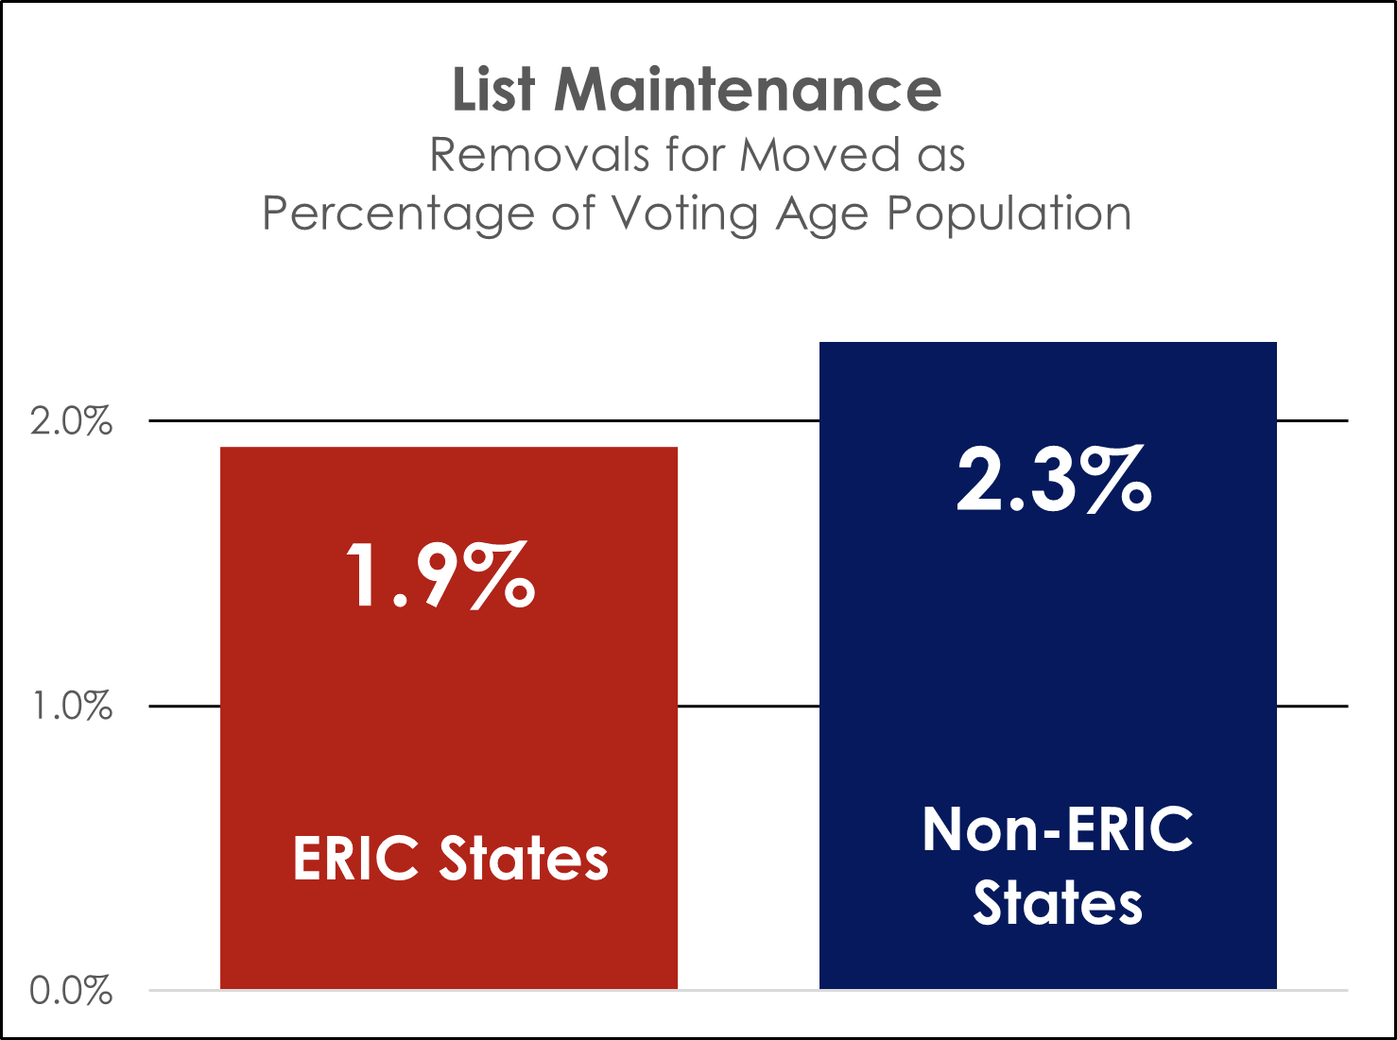 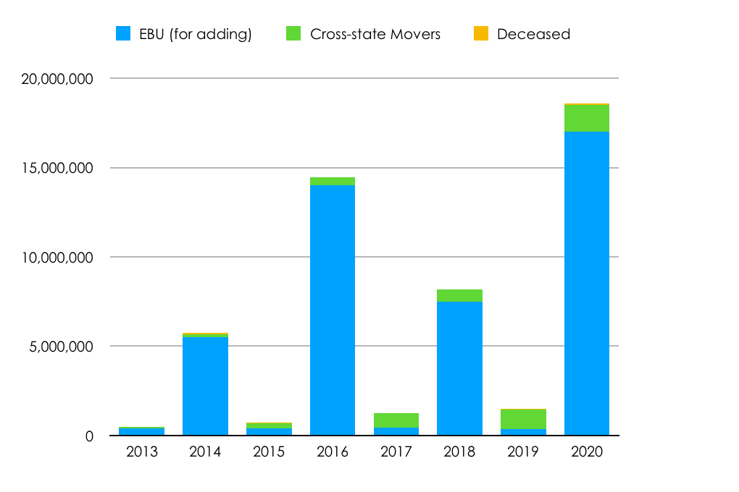

**Conclusions/Requests:**

* The County is responsible for the accuracy of the county’s data and the county’s election results. We have identified Voter Registration Roll accuracy issues in Anoka County.
* We are requesting Anoka County Voter Registration Roll data be audited in full to validate its accuracy level and to identify/remove voters that should not be registered due to ineligibility (MN Statute 201.014), inactivity, or not having registered to vote. ***NOTE: One option to do this is to leverage Omega4America’s offer to examine data. See link** below.***
* We are requesting that by 8/30/2023 we receive a report explaining the audit process and detailed results.

**Links/Resources:**

<https://ericstates.org/who-we-are/> ERIC’s sole mission

<https://verityvote.us/eric-sharing-data-with-zuckerburg-funded-ngo/> Verity Vote Report; see Pages 3 & 4

**[Open Letter to SOS Raffensperger_The Challenge](https://www.thegatewaypundit.com/2023/03/epic-project-omega-sends-letter-to-georgias-secretary-of-state-and-announces-the-raffensperger-challenge-in-honor-of-his-defense-of-the-eric-voter-roll-system/) (Also attached) Offer to examine any county’s ERIC-processed data

