**COUNTING THE VOTE:**

**A Report**

**On the Global Standard of**

**Hand Counting Votes**

**Prepared by**

**Anoka County Election Integrity Team (ACEIT)**

**February, 2023**

**Introduction**

**Paper ballots are by far the most common form of voting globally.**Votes are cast by manually marking ballots in 209 of the 227 countries and territories for which the [ACE Electoral Knowledge Network](http://aceproject.org/about-en/) has data.

**Hand counting of ballots is by far the most common tallying method** with only about 10% of countries using electronic voting machines.

**Source:** <https://www.pewresearch.org/fact-tank/2020/10/30/from-voter-registration-to-mail-in-ballots-how-do-countries-around-the-world-run-their-elections/>

### Manual methods

One method of manual counting is to sort ballots in piles by candidate, and count the number of ballots in each pile. If there is more than one contest on the same sheet of paper, the sorting and counting are repeated for each contest. This method has been used in Burkina Faso, Russia, Sweden, United States (Minnesota), and Zimbabwe.

### When manual counts happen

The tallying may be done at night at the end of the last day of voting, as in Britain, Canada, France, Germany, and Spain, or the next day, or 1–2 weeks later in the US, after [provisional ballots](https://en.wikipedia.org/wiki/Provisional_ballot) have been adjudicated.

**Source**: <https://en.wikipedia.org/wiki/Vote_counting>

**Case Studies**

The following countries hand count ballots. Canada, Finland, France, Germany, Ireland, Netherlands, Norway, Spain, Sweden and the United Kingdom.

* **Canada**

Some CBC News readers have asked us if Elections Canada will still be using paper voter lists at the polls, and if they will be counting ballots by hand once the polls close.

The short answer is yes, on both accounts.

The primary reasons for keeping things low-tech are election security and Elections Canada's high standards for performance, the agency says.

In 2018, the agency planned to run a limited trial of electronic poll books during the fall by-elections. This would have included tablets running a specialized software to help with some tasks, like checking names off the voters' list and completing registration forms.

But before the by-elections could happen Elections Canada says it became clear the technology could not meet the agency's rigorous standards and the agency decided not to deploy the electronic poll books.

Aleksander Essex, an associate professor of software engineering at Western University who specializes in the cybersecurity of voting technology, says the decision to use paper voter rolls is more about reliability than cybersecurity.

"Paper is just reliable," Essex said. "I've worked in federal elections as a deputy returning officer and as a poll worker. And the paper doesn't have a software crash. It's just there."

Much like paper voter rolls, Essex says hand-counting ballots may be a simple system but a good one nonetheless.

"When you count the ballots at the end of the night, you literally open a cardboard box and put them out on the table and you just count them up and the candidate representatives are standing there watching you."

"It's very intuitive and makes a lot of sense," Essex said. "And everyone can witness it with their own eyes.

**Source:** [Why Elections Canada still uses paper voter lists and hand counts ballots for federal elections | CBC News](https://www.cbc.ca/news/politics/ask-paper-voter-lists-hand-counting-ballots-election-1.6167809)

Before the count, election workers close the doors of the voting place. No one is allowed to enter or leave.

Election workers follow all the steps outlined in their counting procedures:

* With many people watching, they unfold each ballot and say aloud the names marked on each ballot.
* Staff tally up the votes, record the tallies on paper, and report the totals to the returning officer, i.e. the official who manages the election for that electoral district.

The returning officer records the vote counts in a computer program that securely sends the information to Elections Canada's main office.

**Source:** [Safeguards for Counting Votes and Reporting on Results – Elections Canada](https://www.elections.ca/content.aspx?section=vot&dir=int/cou&document=index&lang=e)

Counting the votes 283 (1) Immediately after the close of a polling station, the deputy returning officer shall count the votes in the presence of the poll clerk, any person appointed under section 32.1 whose duties include being present at the count and any candidates or their representatives who are present or, if no candidates or representatives are present, at least two electors. (e) open the ballot box and empty its contents onto a table; and (f) examine each ballot, show the ballot to each person who is present, and ask the poll clerk to make a note on the tally sheet beside the name of the candidate for whom the vote was cast for the purpose of arriving at the total number

(Canada Electoral Act 2017, Part 12, Subd. 1 e, f))

**Source:** [Canada: Loi électorale 2017](https://aceproject.org/ero-en/regions/americas/CA/canada-loi-electorale-2017/view)

* **Finland**

Finnish police are probing a cyberattack on a web service that publishes vote tallies less than a week before national elections…There is no electronic voting in Finland. The attack didn’t affect the voting process or the actual counting of ballots, and thus cannot have an impact on the election result, the police said.

**Source:** [Finland Detects Cyber Attack on Online Election-Results Service - BNN Bloomberg](https://www.bnnbloomberg.ca/finland-detects-cyber-attack-on-online-election-results-service-1.1242169)

After the chairperson or the deputy chairperson of the election board has announced that the voting on election day has ended, the ballots shall without delay be taken from the ballot box and counted….

After the ballots have been counted, the election board inspects the ballots. Ballots that are to be regarded as invalid are sorted into their own group. The remaining ballots are sorted into groups so that the ballots given for each candidate are placed in a separate pile. The ballots in each group are counted (preliminary counting of the votes). The election board shall conduct the sorting and counting of the ballots without interruption. After the preliminary counting of the votes has been completed, the ballots, sorted as provided.

**Source:** https://[www.julkalsut.valtioneuvosto.fi](http://www.julkalsut.valtioneuvosto.fi)

* **France**

## PAPER BALLOTS: Voters must be at least 18 years old. About 48.7 million French are registered on the electoral rolls of the place where they live. Voters make their choices in a booth, with the curtains closed, then place their ballot in an envelope that is then put into a transparent ballot box. They must show photo identification and sign a document, next to their name, to complete the process. Volunteers count the ballots one by one. Officials will then use state-run software to register and report results. But legally only the paper counts. If a result is challenged, the paper ballots are recounted manually.

**Source:** [Voting in France: Paper ballots, in person, hand-counted | Europe – Gulf News](https://gulfnews.com/world/europe/voting-in-france-paper-ballots-in-person-hand-counted-1.87097854)

Machine-voting has been allowed on an experimental basis, but the purchase of new machines has been frozen since 2008 due to security concerns. Only about 60 towns still use them, out of 35,000 municipalities in France. Volunteers count the ballots one by one, by hand. Officials then use state-run software to register and report results. But legally only the paper counts. If a result is challenged, the paper ballots are recounted manually.

**Source:** [EXPLAINER: How France's old-school voting system works | AP News](https://apnews.com/article/covid-health-business-elections-france-e06fab5cde84f23d682013e1661caf35)

Each polling place has approximately 1,000 registered voters. During the day, poll workers at each polling place take note when 100 ballots have been cast. At that point the ballots are retrieved and sent to the counting station. This is repeated, each time another 100 ballots have been cast. Therefore, because the bulk of the counting is done during the day, the votes will have been counted within an hour and thirty minutes of the closing of the polls.

**Source:** [How France is Able to Count Votes So Fast | Ballot Access News (ballot-access.org)](https://ballot-access.org/2022/04/24/how-france-is-able-to-count-votes-so-fast/)

* **Germany**

They read your name off the listing and give you a ballot. The ballot is for a party situation.....not a candidate himself or herself.  It's one single sheet. You finish the sheet and push it into a box. At the end of the day.....around a dozen to two-dozen people are there to count ballots (into pile A or pile B).  It's counted by hand, and usually takes about an hour....then repeated.  As long as the numbers come up right after the second count....that's it.

**Source:** [Letters From Ripley: How Does Germany Hand-Count Votes In A Matter Of Three Hours Or Less? (ripleyporch.blogspot.com)](https://ripleyporch.blogspot.com/2022/11/how-does-germany-hand-count-votes-in.html)

Prior to the opening of the ballot box, all unused ballot papers shall be removed from the polling table. The ballot papers shall then be taken from the ballot box, unfolded and counted. At the same time, the number of voting endorsements in the voters’ register and 60 the number of polling cards collected shall be established. (Germany Federal Elections Act, Section 68)

**Source:** [Germany — (aceproject.org)](https://aceproject.org/regions-en/countries-and-territories/DE/default?set_language=en)

Each polling station has several election workers assigned to different tasks. One person checks the completed ballot paper and the personal details, then the voter is noted in the register and we follow up if anyone has any questions. Most people don't spend much time thinking in the booth itself; they've evidently thought beforehand about who they're going to vote for. Then we check to make sure that the sealed envelopes have been correctly placed in the ballot box. We always work for half a day, either from 8 am to 1 pm or from 1 pm to 6 pm. When the polling station is closed, all 10 to 12 helpers get together there again. The envelopes are distributed on tables, everyone takes a pack and counts the votes. At each table the votes are recounted three times by different people, and finally once more in total. Then the secretary enters the result.

**Source:** [Election in Germany | Counting and checking the votes cast (deutschland.de)](https://www.deutschland.de/en/topic/politics/election-in-germany-counting-and-checking-the-votes-cast)

In Germany, mail-in votes are checked against the voter registry as they arrive and [are] kept in a locked ballot box in a secure location until election day to prevent tampering,.. The ballot box for in-person votes is also locked and watched by at least three people from the electoral board to make sure no unauthorized ballots are added. When voting ends at 6 p.m. on election day, the boxes are then opened in the presence of all members of the electoral committee and observers and counted. Federal Returning Officer Georg Thiel, the man responsible for overseeing Germany’s elections, highlighted that the country does not use voting machines, but instead opts for paper ballots that are hand-counted.

**Source**: [Germany Refuses to Use Voting Machines Like US Over Fears of Fraud, Will Only Use Paper Ballots (westernjournal.com)](https://www.westernjournal.com/germany-refuses-use-voting-machines-like-us-fears-fraud-will-use-paper-ballots/)

* **Ireland**

First, there are no electronic voting machines. The government even tried to implement electronic voting, testing it in the 2002 general elections, but the plans were soon abandoned due to criticism from politicians and lack of support from the population. Vows are still made on paper ballots and filled out in pencil…The counting begins the day after the vote, at 9 am, when the ballot boxes are opened and the total number of ballots is counted. Then, the papers are arranged in stacks according to the first candidate voted. Votes are counted and a new count starts, following the order of preference of voters. The process is repeated until all seats in parliament are filled. Although the country does not use electronic voting machines, technology is essential in counting and disseminating votes.

**Source**: [How vote counting works in Ireland’s elections – Oi.ie – Brasileiros na Irlanda](https://oi.ie/en/how-vote-counting-works-in-irelands-elections/?amp)

83. (1) After the ballot papers have been mixed in accordance with rule 79, the returning officer shall, rejecting any that are invalid, arrange them in parcels according to the first preferences recorded for each candidate. (2) The returning officer shall then count the number of papers in each parcel and credit each candidate with a number of votes equal to the number of valid papers on which a first preference has been recorded for such candidate and the returning officer shall ascertain the number of all valid papers (European Parliament Elections Act, p. 68)

**Source:** European Parliament Elections Act Ireland.pdf

* **Netherlands**

The [Dutch government](https://www.independent.co.uk/search/site/netherlands?CMP=ILC-refresh) has decided to hand count all ballots in its next election and to ditch its "vulnerable" counting software to prevent potential hackers from influencing the outcome….

In previous elections, the ballots were counted by hand locally but regional and national counts were done electronically. But this year, all ballots will be counted by hand after voters make their choice on 15 March.

**Source**: [Netherlands Will Hand Count Election Votes Over Hacking Fears (businessinsider.com)](https://www.businessinsider.com/netherlands-will-hand-count-election-votes-over-hacking-fears-2017-2)

Paper ballots used in Dutch elections are usually counted by hand at local polling stations, before being processed electronically on a regional and then national level. The Dutch Electoral Commission this week said it was probing potential vulnerabilities in the software used in the counting phase. That followed local media reports that weaknesses in the system made it easy to hack into. Some 12.6 million Dutch voters are eligible to cast ballots in the election.

**Source**: [Dutch to hand-count eletion ballots – DW – 02/01/2017](https://www.dw.com/en/dutch-to-hand-count-ballots-in-march-vote-due-to-hacking-fears/a-37375137)

Section N 1 1. Immediately after voting has ended, the electoral committee shall determine: (a) the number of voters who presented themselves; (b) the number of ballot papers issued; (c) the number of voters who refused to place the ballot paper in the ballot box; (d) the number of ballot papers returned and rendered unusable; (e) the number of unused ballot papers; (f) the number of authorisations used to cast a proxy vote.

Section N 4 The ballot papers shall be counted and their number compared with the number of voters who voted.

Section N 5 The members of the electoral committee shall open the ballot papers and sort them by list. They may be assisted in this work by alternate members and by officials of the municipality designated for this purpose by the municipal executive. Section N 6 1. The electoral committee shall determine in respect of each list: (a) the number of votes cast for each candidate; (b) the sum of the numbers of votes referred to at (a). (Netherlands Election Act, 2010, Chapter N, Subd. 1, 4, 5)

**Source:** pdf-voor-engelse-site-elections-act-2010.pdf

* **Norway**

Norway is the second country in Europe to change the way it counts votes. The Netherlands decided to count its March 15 parliamentary elections manually after broadcaster [RTL](https://www.rtlnieuws.nl/nederland/politiek/met-potlood-stemmen-onveilig-verkiezingsuitslag-eenvoudig-te-hacken)  interviewed security experts and hackers who said software security was weak. One hacker claimed an average iPad is better protected than the Dutch electoral system. Minister of Local Government and Modernization, Jan Tore Sanner, says security measures also for computer systems will be enhanced.

«Security and trust are vital to the conduct of elections. We shall not be naïve, nor allow for any uncertainty around the security of Norwegian elections. The voters will rest assured that the election results are accurate. After new threat assessments undertaken in collaboration with the NSM and PST, we have decided to initiate additional security measures, says Sanner.»

**Source**: [Norwegian votes to be counted manually in fear of election hacking | The Independent Barents Observer (thebarentsobserver.com)](https://thebarentsobserver.com/en/life-and-public/2017/09/norwegian-votes-be-counted-manually-fear-election-hacking)

After polling has been concluded the votes shall be counted. Ballot papers cast in advance and ballot papers cast at electoral proceedings shall be kept apart and registered separately. The counting of ballot papers takes place in two rounds: a provisional count and a final count.

**Source:** [The main features of the Norwegian electoral system - regjeringen.no](https://www.regjeringen.no/en/topics/elections-and-democracy/den-norske-valgordningen/the-norwegian-electoral-system/id456636/)

[Norway — (aceproject.org)](https://aceproject.org/regions-en/countries-and-territories/NO/default?set_language=en)

* **Spain**

Section 95. Counting of votes: 1. On conclusion of the voting the count (escrutinio) shall begin immediately. 2. The count shall be conducted in public and shall not be suspended, except by reason of force majeure, even if more than one election are being held at the same time. The presiding officer shall cause a person who has in any way disturbed or obstructed the operations to be immediately expelled from the premises 3. In the event of more than one election being held concurrently, the count shall proceed in the following order: (1) the European Parliament, (2) the Congress of Deputies (3) the Senate, (4) Local Councils, (5) Legislative Assemblies of Self-Governing Communities and finally the Canary Islands’ Insular Councils (Cabildos Insulares). 4. The count shall be carried out with the presiding officer extracting the envelopes one by one from the corresponding ballot box and reading out the name of the candidates list or, as the case may be, of the candidates. He shall also read each ballot paper himself and then show it to the other members of the Bureau, to polling controllers and to election proxies. (Representation of the People Institutional Act, Chapter VI, 14th Subdivision, Sections 1-4)

**Source**: Representation of the People Institutional Act.pdf

* **Sweden**

Unlike in many countries where voters chose from a list of candidates or parties, each party in Sweden has separate ballot papers. The ballot papers must be identical in size and material, and have different colors depending on the type of election: yellow for Riksdag elections, blue for county council elections and white for municipal elections and elections to the European Parliament.

Sweden uses [open lists](https://en.wikipedia.org/wiki/Open_list) and utilizes [apparentment](https://en.wikipedia.org/wiki/Apparentment" \o "Apparentment) between lists of the same party and constituency to form a *cartel*, a group of lists that are legally allied for purposes of seat allocation.[[3]](https://en.wikipedia.org/wiki/Elections_in_Sweden#cite_note-FOOTNOTECox199761-3) A single preference vote may be indicated as well.[[4]](https://en.wikipedia.org/wiki/Elections_in_Sweden#cite_note-FOOTNOTEElections12-4)

Swedish voters can choose between three different types of ballot papers. The *party ballot paper* has simply the name of a political party printed on the front and is blank on the back. This ballot is used when a voter wishes to vote for a particular party, but does not wish to give preference to a particular candidate. The *name ballot paper* has a party name followed by a list of candidates (which can continue on the other side). A voter using this ballot can choose (but is not required) to cast a personal vote by entering a mark next to a particular candidate, in addition to voting for their political party. Alternatively, a voter can take a *blank ballot paper* and write a party name on it.[[5]](https://en.wikipedia.org/wiki/Elections_in_Sweden#cite_note-FOOTNOTEElections7-5) Finally, if a party hasn't registered its candidates with the election authority, it is possible for a voter to manually write the name of an arbitrary candidate. In reality, this option is almost exclusively available when voting for unestablished parties. However, it has occasionally caused individuals to be elected into the city council to represent parties they don't even support as a result of a single voter's vote.[[6]](https://en.wikipedia.org/wiki/Elections_in_Sweden#cite_note-6)

**Source:** https://en.wikipedia.org/wiki/Elections_in_Sweden

Chapter 11. Preliminary counting of votes at a polling station Registration of party denomination Section 1 Immediately after vote reception at the polling station is concluded and all vote envelopes that shall be placed in the ballot box have been deposited in it, the voting clerks shall take out the envelopes and count the votes. The counting of votes is public and shall be implemented without interruption. The result of the counting of votes is preliminary. Section 2 If an election to the Riksdag has been held at the same time as another election, the election to the Riksdag shall be counted first. The count shall for each kind of election be conducted in the following way: 1. The ballot box shall be emptied and the vote envelopes counted. The number of voters who according to the electoral roll participated in the election shall be counted. 2. The ballot papers shall be taken out of the vote envelopes. If a vote envelope contains more than one ballot paper, the ballot papers shall not be approved but be re-inserted into the envelope. 3. A ballot paper that may be assumed to be invalid in accordance with Chapter 13, Section 7, first paragraph, item 1 shall not be approved. 4. A ballot paper that may be assumed to be invalid according to any of the grounds referred to in Chapter 13, Section 7, shall not be approved but re-inserted into its vote envelope. 5. Ballot papers and vote envelopes as referred to in items 2–4 shall be inserted into special covers. 6. The ballot papers that are approved shall be sorted in 50 the elections act groups according to party denomination. The number of ballot papers in each group shall be counted. The ballot papers for each party shall then be inserted into special covers. (The Elections Act, Part III, Chapter 11, page 50)

**Source:** elections act sweden (1).pdf

* **United Kingdom**

The counting itself is done by temporary staff known as, well, counters. They work in teams, under supervisors…

## Stage 1: counting the ballot papers

The count opens with the ceremonial unsealing of the ballot boxes, both those from the polling stations and those containing the postal ballots, which have already been opened and verified but the actual votes not yet counted. The ballot papers are emptied on to the counting tables, and, in the manner of a stage magician, the emptiness of the boxes displayed to the assembled observers.

All ballot papers are then counted, the counters ensuring the number of papers in each box matches the ballot paper account – the form completed by the presiding officer at either the polling station or the opening and verification of the postal ballot packs.

If the numbers don’t match, there are recounts until they do match or the same number of ballots is recorded twice in succession.

## Stage 2: counting the votes

First, ballot papers from different boxes are mixed, to preserve the secrecy of the vote. They are then allocated to count teams, who sort the papers by the candidate voted for – each voter in the UK’s plurality electoral system being allowed, of course, only one unambiguous X vote.

If the voter’s X is not clearly in the box next to a candidate, it becomes a “doubtful” paper, with the ARO or deputy adjudicating on its validity. But nowadays, the aim is to divine the voter’s intention wherever possible, and only where it is completely unclear or disputed is the ballot paper actually rejected.

With “Wank, wank, good guy, wank” having been recently [deemed a valid vote](http://www.buzzfeed.com/jamieross/reasons-you-should-register-to-vote-by-mondays-deadline) (cast for the SNP), it’s reasonably safe to say a tick, a “Yes”, or a smiley face are all likely to be accepted. If a candidate’s agent objects, the objection is recorded, but again, it’s ultimately the ARO’s decision.

With sorting completed, each candidate’s votes are then counted, plus any rejected votes, and the total checked against the total number of ballot papers recorded in the first count.

**Source**: [Explainer: how Britain counts its votes (theconversation.com)](https://theconversation.com/explainer-how-britain-counts-its-votes-41265)

First stage of the count: counting the number of ballot papers At this stage count staff will be comparing the actual numbers of ballot papers in each ballot box against the ballot paper account. This is a form completed by the Presiding Officer at each polling station accounting for the ballot papers they have issued. Postal votes are accounted for in a similar way. Ballot boxes are opened and emptied onto tables. The empty boxes are shown to everyone present. Count teams count and record the number of ballot papers in each ballot box. Where the number of ballot papers matches the number expected, the ballot papers are ready to go to the second stage of the count. Where they don’t, the count team will be asked to recount the ballot papers until the numbers match or until the same number of ballot papers is arrived at twice in a row. Any discrepancies between the numbers on the ballot paper account and those in the ballot box are recorded. The (A)RO will prepare a statement showing how many ballot papers were received in each ballot box against how many ballot papers were expected. This statement will be provided to candidates and agents.

Second stage of the count: counting the votes on the ballot papers Ballot papers from different ballot boxes are mixed to preserve the secrecy of the vote. Ballot papers are then allocated to count teams which will sort ballot papers by candidate. Ballot papers that are not marked with an ‘X’ in the box next to a candidate are given to the (A)RO, or a deputy, to adjudicate – these are called ‘doubtful’ ballot papers. As long as the intention of the voter is clearly apparent, the vote can be accepted as valid and be counted. (Brochure: The Electoral Commission—Counting the Votes at a UK Parliamentary general election)

**Source**: [UKPGE - easy guide to the count - FINAL FILE - DL Leaflet (electoralcommission.org.uk)](https://www.electoralcommission.org.uk/sites/default/files/pdf_file/UKPGE-easy-guide-to-the-count-FINAL-FILE-DL-Leaflet.pdf)

**General Sources:**

* [www.aceproject.org](http://www.aceproject.org)  (This source has election laws for each country)
* *Oxford Handbook of Election Systems*
* Wikipedia entries

**Why European countries hand count “ballot papers:”**

1. Citizens expect transparency and open public process.

2. Citizens value hand counting tradition.

3. Machines were tested in pilot projects but performance standards were not met.

5. Public distrust of tabulation machines.

6. Public trust in laws setting clear procedures for handling “ballot papers.”

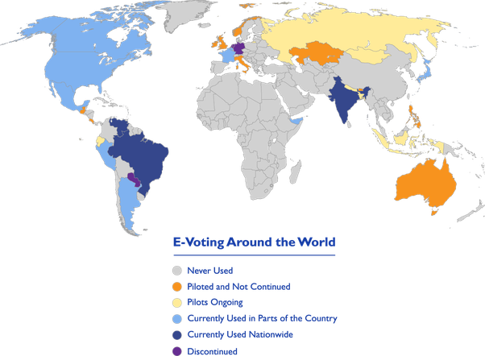

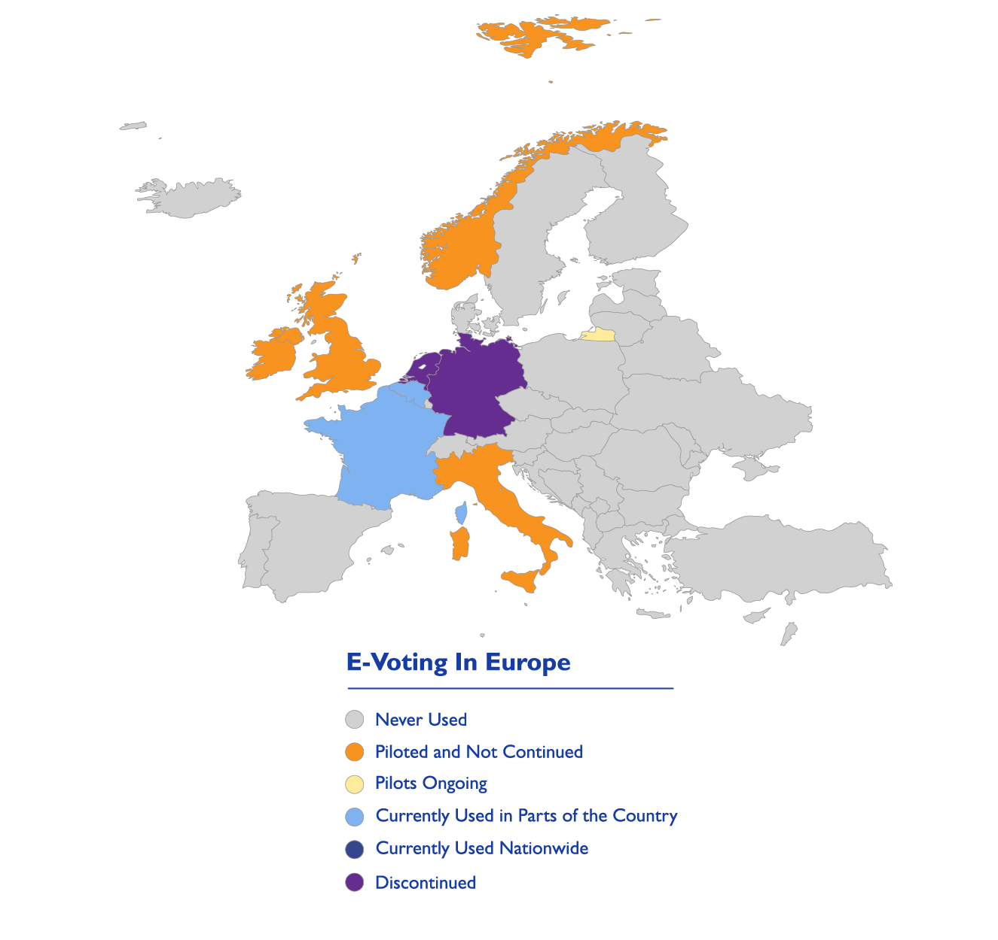

**Source**: <https://www.ndi.org/e-voting-guide/electronic-voting-and-counting-around-the-world>